### Dataset:

<https://docs.google.com/spreadsheets/d/1-Zo-A4gnlLOQxpU8qgpkTJPJCS8cQBmNzKVirJ_Ow0w/edit?usp=sharing>

### Use the above dataset and answer the following questions. Assume that a gang is trying to loot Diamonds and Soft drinks being exported from India

### 1. How much Diamonds were looted from Chennai Port Trust?

#### Ans:

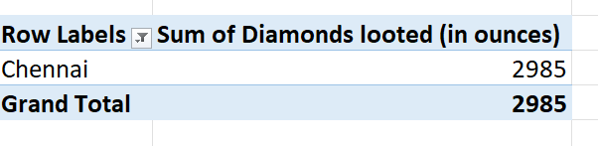

### 2. How many Ships were looted near Paradip Port Trust and Chennai Port Trust?

#### Ans:

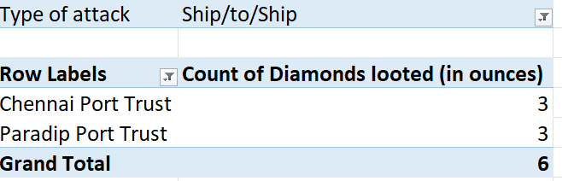

### 3. What is the sum total of Diamonds looted from the V.O. Chidambarnar port trust?

#### Ans:

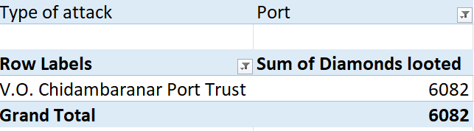

### 4. What is the average amount of Diamonds and Soft drinks looted?

#### Ans:

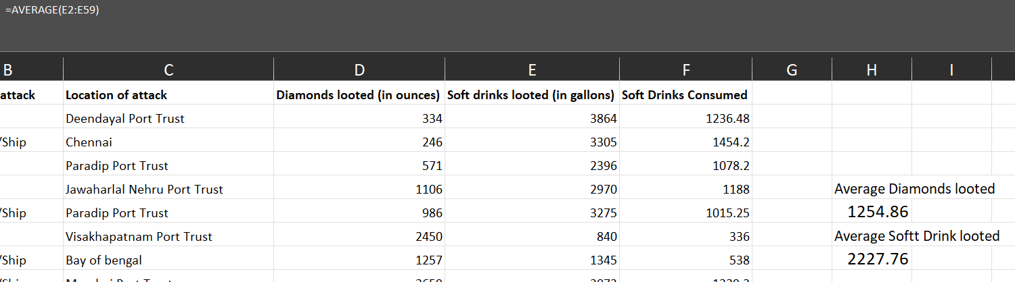

### 5. What is the ratio of soft drinks drunk to soft drinks looted?

#### Ans:

